LLM: aims to predict and generate possible language

- estimate probability of token

- Transformers to process tokens

input: text output: text, numeric value for other system

Token: (data) a word that we understand

Tokenizer: divides text in tokens then passed to a transformer

Transformers: a machine learning model [encoder, decoder] dispurses data to a bunch of layers. Gives importance to words.

Embedding: gives meaning to the words for machine, tokens get converted into numeric vectors

Vectors: are stored in a Vector Store Database which is a space to store, search, and manage vectors

Parser: tool that helps analyze and extract infromation from an HTML doc

Retrieval

Augmented

Generation

RAG: combines the strengths of retrieval-based methods and generation-based methods to provide more accurate and contextually relevant responses

local db for VSD

Llama_2_7b_chroma: Large Language Model Meta AI, the 2nd version of a family of large language models developed by Meta (formerly Facebook). ‘7B’ stands for 7 billion parameters, making it one of the larger variants of the LLaMA model series. Llama 2 is an auto-regressive language model that uses an optimized transformer architecture. The tuned versions use supervised fine-tuning (SFT) and reinforcement learning with human feedback (RLHF) to align to human preferences for helpfulness and safety. Llama 2 comes in a range of parameter sizes — 7B, 13B, and 70B — as well as pretrained and fine-tuned variations.

Mini LM L6 v2: is intended to be used as a sentence and short paragraph encoder. Given an input text, it outputs a vector which captures the semantic information. The sentence vector may be used for information retrieval, clustering or sentence similarity tasks.It maps sentences & paragraphs to a 384 dimensional dense vector space and can be used for tasks like clustering or semantic search.

Batch size explained:

* **Larger Batches**: Larger batch sizes can lead to more efficient use of the GPU, reducing the overhead associated with each batch and speeding up the overall computation.
* **Smaller Batches**: Smaller batch sizes can help with convergence during training, as they introduce more noise into the gradient updates, which can act as a form of regularization.
* 16, 32, 64, 128, 256, 512

dummy text file for drive for llama notebook:

[game of thrones book](https://drive.google.com/drive/folders/1rqbb0CDWNJ20w3ItzR1VTphfJRIDGQmf)

<https://www.kaggle.com/code/himanshunayal/game-of-thrones-gensim/input>

Chromadb: used for managing and querying vector stores.

To add to DB: collection.add(ids=str(idx), embeddings=embedding, documents=chunk)

To delete DB: chroma_client.delete_collection(name=collection_name)

embeddings: will be stored in the ChromaDB vector store. When a query is made, you can compare the query's embedding with the stored embeddings to find the most relevant chunks of text from the book.

rag_pipeline: retrieval-augmented generation pipeline, combines retrieval (finding relevant documents) with generation (creating coherent text) to provide answers to questions based on a corpus of documents. Returns a dictionary of the answers of the given questions as well as other data that was useful in coming up with an answer.  
  
How to run Colab on local GPU:  
<https://www.youtube.com/watch?v=vAZpM_LxrXM>

<http://localhost:8888/tree>

python -m notebook --NotebookApp.allow_origin='https://colab.research.google.com' --port=8888 --NotebookApp.port_retries=0

**TRIAL RESULTS: Using these** *[four runs]* **to get familiar with the models used.**

**Using OpenAI metrics API to measure: Answer Correctness**

**Answer Correctness:** To measure how correct and accurate the generated answer is in an objective sense. Assessing the correctness of the answer, which is critical for tasks requiring high accuracy. A high score (close to 1) signifies that the generated answers are highly accurate compared to the ground truth. Lower scores suggest that the answers may contain inaccuracies.

*[1st run]*:

**Model Setup**:

* MiniLM L6:
  + Batch size = 32
* Llama 7B:
  + Temperature = 1.0
  + Max new tokens = 500
  + Repetition penalty = 1.1
* Text splitter:
  + Chunk size: 50

Results from easy questions:

1. 0.20176102072352
2. 0.197841225143486
3. 0.194237590508863
4. 0.542093029738119
5. 0.723624136836856
6. 0.737965655171898
7. 0.437777079913179
8. 0.230063837390609
9. 0.736940111400159
10. 0.469725897277111
11. 0.79340126049283
12. 0.643077534274237
13. 0.222182801934244

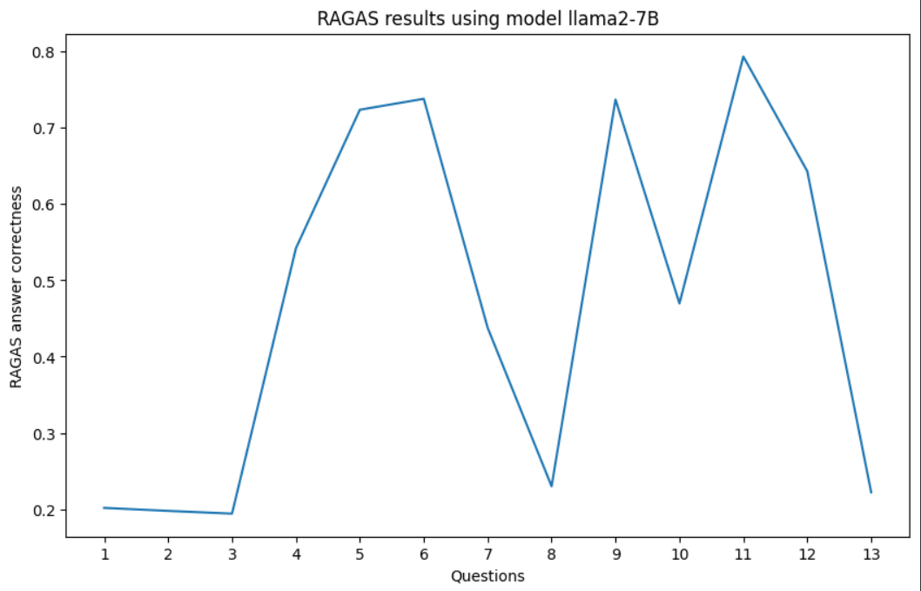

Easy questions:

1. What is the book's name?
2. Who is the main character?
3. What is the book about?
4. Who is the 'Hound'?
5. Are dragons mentioned?
6. What is the Iron Throne?
7. Who is Daenerys Targaryen?
8. Who are the members of House Stark?
9. Who is Jon Snow?
10. What is the significance of Winterfell?
11. What is the Wall in the book?
12. What is the significance of Dragonstone?
13. What is the role of the maesters?

Easy answers:

1. The book's name is "The Princess Bride".
2. Based on the text you provided, the main character appears to be the "last hero" who died. However, without more context, I can't provide a definitive answer. Can you provide more information or context about the story?
3. The book is a rumination on the nature of truth and its relationship with old books.
4. Sandor Clegane, also known as the Hound.
5. Yes, dragons are mentioned in the passage. The passage refers to "dragons" multiple times, including in the phrase "there be dragons too?" and in the sentence "perhaps the last dragons anywhere." It also mentions specific instances of dragons, such as those owned by Lord Targaryen and those on the walls of Dragonstone.
6. The Iron Throne is a symbol of power and rule over the Seven Kingdoms in the fictional world of Westeros in the book series "A Song of Ice and Fire" by George R.R. Martin. It is located in the Red Keep of King's Landing and is the seat of the ruling monarch of the Seven Kingdoms.
7. She is the last member of House Targaryen, which was once one of the most powerful families in Westeros.
8. According to the passage, the members of House Stark are:
9. Jon Snow is a character from the Game of Thrones book series by George R.R. Martin and the TV series adaptation by HBO. He is a bastard son of Ned Stark, and later becomes a member of the Night's Watch.
10. Winterfell is a significant location in the Game of Thrones series. It is the home of House Stark, one of the most powerful families in Westeros, and has played a central role in many important events throughout the story. Winterfell is also known for its beauty and its connections to the mythology of the First Men, who built the castle and named it after the goddess of ice and winter, Morghul-e-Shadow.
11. In the A Song of Ice and Fire series, the Wall is a massive structure that runs along the northern border of Westeros, separating the Seven Kingdoms from the lands beyond. It is a barrier of ice and stone, built to protect the kingdoms from the threats that come from beyond the Wall. The Wall is also home to the Night's Watch, an organization of sworn brothers who are tasked with guarding the Wall and protecting the realm from dangers such as wildlings, White Walkers, and other supernatural threats.
12. Ah, a very good question! It seems that Dragonstone is significant in the world of Game of Thrones as it is the ancient seat of the Targaryen dynasty and the final resting place of many Targaryen kings. It is also where Daenerys Targaryen spent her youth after she was exiled from Winterfell by her evil uncle, King Joffrey. Additionally, it is the location where Jon Snow was taken as a child to be fostered, and it holds great cultural and historical importance to the Targaryen people.
13. According to the text provided, the role of the maesters appears to be:

Ground Truth:

1. A Game of Thrones
2. There isn't a single main character in 'A Game of Thrones' as the book follows multiple characters, including Eddard (Ned) Stark, Jon Snow, Daenerys Targaryen, Tyrion Lannister, and others.
3. 'A Game of Thrones' is the first book in the 'A Song of Ice and Fire' series by George R.R. Martin. It is set in the fictional continents of Westeros and Essos and follows the power struggles among noble families as they vie for control of the Iron Throne of the Seven Kingdoms.
4. Sandor Clegane is known as the 'Hound'. He is a fierce warrior known for his brutal tactics and scarred face.
5. Yes, dragons are mentioned in 'A Game of Thrones'. Daenerys Targaryen is gifted three dragon eggs, which eventually hatch into dragons.
6. The Iron Throne is the throne of the ruler of the Seven Kingdoms of Westeros. It is made from the swords of the vanquished enemies of Aegon the Conqueror, who was the first king to rule over a united Westeros.
7. Daenerys Targaryen, also known as Dany or Khaleesi, is one of the last surviving members of House Targaryen, a family that was overthrown from the Iron Throne. She is determined to reclaim the throne and rule the Seven Kingdoms.
8. The primary members of House Stark include Eddard (Ned) Stark, Catelyn Stark, Robb Stark, Sansa Stark, Arya Stark, Bran Stark, Rickon Stark, and Jon Snow (Eddard's illegitimate son, though he is raised as part of the family).
9. Jon Snow is the illegitimate son of Eddard Stark, raised at Winterfell alongside Eddard's legitimate children. He joins the Night's Watch, a brotherhood tasked with guarding the northern borders of the Seven Kingdoms.
10. Winterfell is the ancestral castle and seat of House Stark, located in the North of Westeros. It is a central location in the series and represents the Stark family's legacy and honor.
11. The Wall is a massive ice structure that separates the Seven Kingdoms from the lands beyond to the north. It is manned by the Night's Watch, who protect the realm from the dangers that lie beyond, including wildlings and mythical creatures.
12. Dragonstone is the ancestral seat of House Targaryen in Westeros. It is a castle located on an island of the same name and is significant due to its strategic location and historical importance as the Targaryens' first stronghold in Westeros.
13. The maesters are an order of scholars, healers, and learned men who serve the various castles and noble houses of Westeros. They provide medical care, advice, and education, and are responsible for sending and receiving messages through their network of ravens.

Results from hard questions:

1. 0.452159932086898
2. 0.474076064150522
3. 0.730943120163458
4. 0.451655444858428
5. 0.210172763602857
6. 0.330870435311371
7. 0.676328936129762
8. 0.990560799009658
9. 0.881696764532841
10. 0.881696764532841

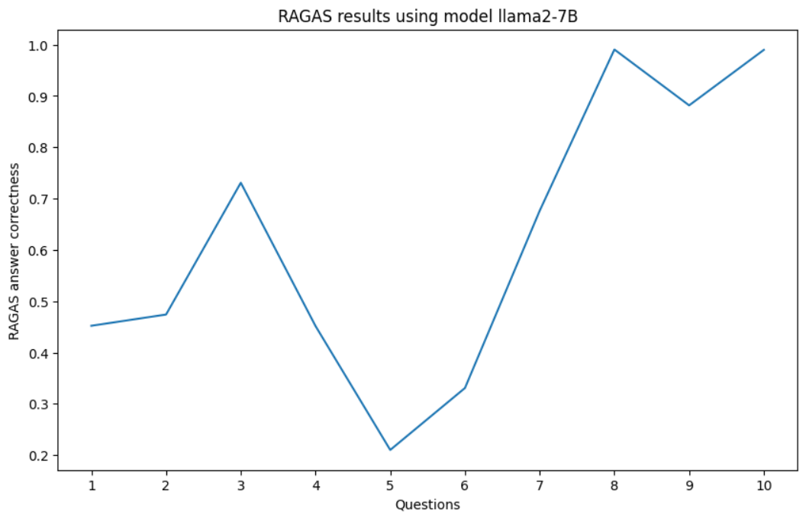

Hard Questions:

1. What are the political implications of Eddard Stark's appointment as Hand of the King?
2. How does the power struggle between the houses affect the stability of the Seven Kingdoms?
3. What is the significance of Jon Snow's parentage and how does it impact his character's development?
4. How do the different religions in the book influence the characters and their actions?
5. What is the role of prophecy and visions in shaping the events?
6. How does the concept of honor versus pragmatism play out in the actions of the main characters?
7. What are the consequences of Daenerys Targaryen's decisions in her quest to reclaim the Iron Throne?
8. How does the theme of identity and transformation manifest in characters like Arya Stark and Sansa Stark?
9. What is the significance of the Iron Bank of Braavos in the political landscape of Westeros?
10. How does the geography of Westeros and Essos influence the strategies and outcomes of battles and wars?

Hard answers:

1. Eddard Stark's appointment as Hand of the King has significant political implications. As a trusted advisor to the King, Lord Stark will have access to the king's ear and influence his decisions. He may be able to temper the King's more rash decisions or advise him on matters of statecraft. Additionally, the position of Hand is often used as a tool for power brokering within the realm, so it is possible that Eddard Stark could use this position to gain favor with the King and potentially rise in power himself. However, given his honorable nature, it is also likely that Lord Stark will use this position solely for the good of the realm.
2. The power struggle between the houses has a significant impact on the stability of the Seven Kingdoms as each house tries to increase their power and influence over the others, leading to conflicts and tensions that can threaten the very foundation of the realm.
3. In A Song of Ice and Fire, Jon Snow's parentage is significant because it reveals a secret about his true identity, which has far-reaching consequences for his life and relationships. As the illegitimate son of Lord Eddard Stark, Jon is not technically a member of House Stark or the North, which creates tension and conflict throughout the series. Jon's status also affects his relationship with his siblings, particularly Sansa and Arya, who struggle to accept him as a true member of their family. Additionally, Jon's connection to his mother, Lyanna Stark, raises questions about the nature of his parentage and Lyanna's motivations, adding complexity to the story. Throughout the series, Jon struggles with his sense of belonging and purpose, which are closely tied to his understanding of his parentage. This theme is central to Jon's character development and plays a crucial role in the plot of the entire series.
4. Each religion has its own set of beliefs, practices, and deities, which shape the worldview and actions of the characters who follow it. For example, the Faith of the Seven is a major religion in Westeros, and its teachings on obedience and compliance with authority may influence the actions of characters like Cersei Lannister or Margaery Tyrell. Similarly, the old gods and the worship of the Secret Gods may inspire characters like the Starks and the children of the forest to act in certain ways. Understanding how these religions impact the characters can provide valuable insight into their motivations and decisions throughout the series.
5. The ancient prophecy foretold of a child who would unite the land, but it was unclear whether this child would be a savior or a source of danger. In response to the prophecy, those in power took drastic measures to ensure their own survival, such as killing the child or attempting to manipulate him/her through various means.
6. Based on the provided passages, it seems that honor plays a significant role in the decisions and actions of some of the main characters, particularly those from the First Men culture. For example, Jaime Lannister values his honor and loyalty to the Kingsguard, even when it goes against his personal interests or morals. Similarly, Daenerys Targaryen sees her struggle for the Iron Throne as a matter of restoring her family's honor and legacy. In contrast, other characters like Tyrion Lannister and Jon Snow seem less concerned with honor and more focused on practicality and survival. So, it seems that the concept of honor versus pragmatism is a central theme in the story, and different characters have different attitudes towards it.
7. I cannot predict the exact consequences of Daenerys Targaryen's decisions without more information about the specific actions she takes and their context within the story. However, I can provide some general information about the Targaryen succession and the potential consequences of Daenerys' actions based on what is shown in the passage.
8. The theme of identity and transformation is evident in both Arya and Sansa's experiences throughout the series. Arya undergoes a significant transformation from a childish and impulsive tomboy into a stealthy and cunning warrior, shedding her old identity as she faces challenges on her journey. Similarly, Sansa transforms from a naive and trusting young girl into a resourceful and determined survivor, adapting to the harsh realities of the world around her. Through these character arcs, the authors explore the idea that our identities are shaped by our experiences and the choices we make, leading to both personal growth and loss of innocence.
9. The Iron Bank of Braavos is one of the most powerful financial institutions in Westeros, with significant influence over the political affairs of the continent. It has provided loans and financial support to various factions and individuals throughout the series, often with the intention of exerting indirect control over their actions. The bank has also been known to use its vast wealth and resources to manipulate events and outcomes, making it a major player in the game of thrones.
10. The Iron Bank of Braavos is one of the most powerful financial institutions in Westeros, with significant influence over the political affairs of the continent. It has provided loans and financial support to various factions and individuals throughout the series, often with the intention of exerting indirect control over their actions. The bank has also been known to use its vast wealth and resources to manipulate events and outcomes, making it a major player in the game of thrones.

Ground Truth:

1. Eddard Stark's appointment as Hand of the King brings the Stark family into the heart of political intrigue in King's Landing, balancing the power between the North and South but also leading to his downfall and the War of the Five Kings.
2. The power struggle between major houses leads to significant instability, civil war, and vulnerability to external threats like the White Walkers.
3. The power struggle between major houses leads to significant instability, civil war, and vulnerability to external threats like the White Walkers.
4. Different religions in the book influence characters' decisions and actions by providing different moral frameworks and justifications.
5. Prophecies and visions drive characters to make significant decisions, often leading to unexpected and sometimes tragic outcomes.
6. The conflict between honor and pragmatism is a central theme, with honorable actions often leading to ruin and pragmatic decisions resulting in survival and success.
7. Daenerys Targaryen's decisions in her quest to reclaim the Iron Throne have far-reaching consequences, earning her a reputation as a liberator but also creating powerful enemies.
8. The theme of identity and transformation is vividly portrayed in Arya and Sansa Stark, who undergo significant personal growth through their experiences.
9. The Iron Bank of Braavos plays a crucial role in the political landscape by providing financial support that can determine the outcome of wars and power struggles.
10. The geography of Westeros and Essos influences military strategies and outcomes, with natural features serving as both barriers and strategic advantages.

*[2nd run]*:

**Model Setup**:

* MiniLM L6:
  + Batch size = 16
* Llama 7B:
  + Temperature = 0.8
  + Max new tokens = 300
  + Repetition penalty = 1.4
* Text splitter:
  + Chunk size: 100

Results from easy questions:

1. 0.188713439692156
2. 1
3. 0.226828303465929
4. 0.235119961998875
5. 0.209574483648385
6. 0.208314809928236
7. 0.208968557163083
8. 0.222449366865683
9. 0.974827715679984
10. 0.221096413353217
11. 0.220643993536234
12. 0.22369174347667
13. 0.197093241734905

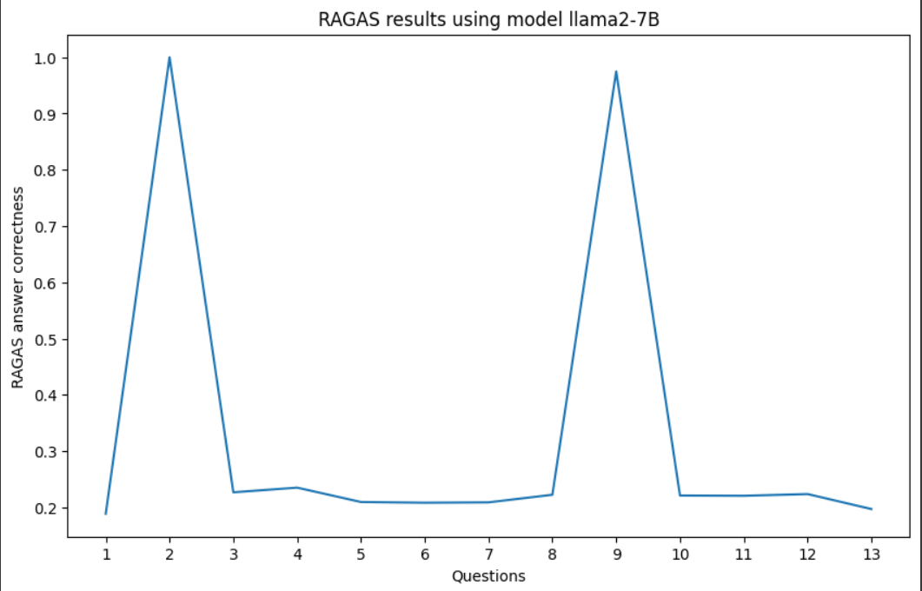

Easy questions:

1. Who is the author of the book?
2. What is the name of the Stark family’s ancestral home?
3. Who is the head of House Stark at the beginning of the book?
4. What is the name of Ned Stark’s wife?
5. Who is the King of the Seven Kingdoms when the story begins?
6. What is the name of Ned and Catelyn Stark’s eldest son?
7. Who is the dwarf son of Tywin Lannister?
8. What is the motto of House Stark?
9. What is the name of Jon Snow’s direwolf?
10. Who is the youngest Stark daughter?
11. Which character is known as the Mother of Dragons?
12. What is the name of the continent where most of the story takes place?
13. Who pushes Bran Stark from the tower window?

Easy answers:

1. You have provided me with too little information for me to determine who the author of this particular book might be! The passage doesn't give any clues about the identity or background of the person responsible for writing it; therefore, without additional details (e.g., title page citations), I cannot confidently state their name.
2. Winterfell
3. At the beginning of A Game Of Thrones (book 1), the head of House Stark is Eddard Stark.
4. Wife - Catelyn Stark (mentioned in passage)
5. According to George RR Martin himself in interviews and essays/articles published online (not fanfiction or speculation), there are no established "King" positions among any factions fighting for control over Westeros during A Song Of Ice And Fire events depicted thus far nor has anyone been crowned as such because none of them can agree on who should be their leader due to various political agendas caused by years of civil war throughout different eras which makes identifying someone with absolute authority impossible without outside influence like dragonfire or some magical artifact being involved firsthand through personal experiences while reading those sources I do understand how intricate this worldbuilding may seem sometimes but rest assured your patience will reward thee richly if thou keepeth exploring further into these realms built carefully across multiple seasons so feel free now proceed forward knowing what lies ahead before thy eyes!
6. I can see from the text provided above (emphasis added) that the names of Ned and Catlyn Starks are EDWARD & CATILYN respectively!
7. I cannot determine from this passage whether or not there is a dwarf son of Tywin Lannister because it does not mention such information in any way directly related to your search query (dwarf son).
8. The motto of House Stark is "Winter Is Coming."
9. Ghost!
10. Ah, I see! Well... according to the text provided, the youngest Stark daughter is Arya Stark.
11. According to the provided text passage, it appears that Daenaera Velaryon (also called "Mother of Dragons") holds this title due to having given birth to several generations worth of dragondrakes through a magical ritual involving powerful magic from Valyria.
12. Based on the text provided in your post, it seems clear that most of the story takes place on a single continents called "Westeros".
13. It is not explicitly stated in the text who pushed Bran Stark out of the tower window. However, it has been suggested by fans and readers alike that Meera Reed may have played some role in pushing or throwing Bran out of the window as she was known for her abilities with magic and had previously helped protect Bran during their journey together.

Ground Truth:

1. George R. R. Martin
2. Winterfell
3. Eddard (Ned) Stark
4. Catelyn Stark
5. Robert Baratheon
6. Robb Stark
7. Tyrion Lannister
8. Winter is Coming
9. Ghost
10. Arya Stark
11. Daenerys Targaryen
12. Westeros
13. Jaime Lannister

Results from hard questions:

1. 0.201219527933205
2. 0.725119198433069
3. 0.18296265060137
4. 0.188014575895891
5. 0.185996936549621
6. 0.198889873278611
7. 0.196828216973192
8. 0.190485699751255
9. 0.817726816467955
10. 0.207929522214062

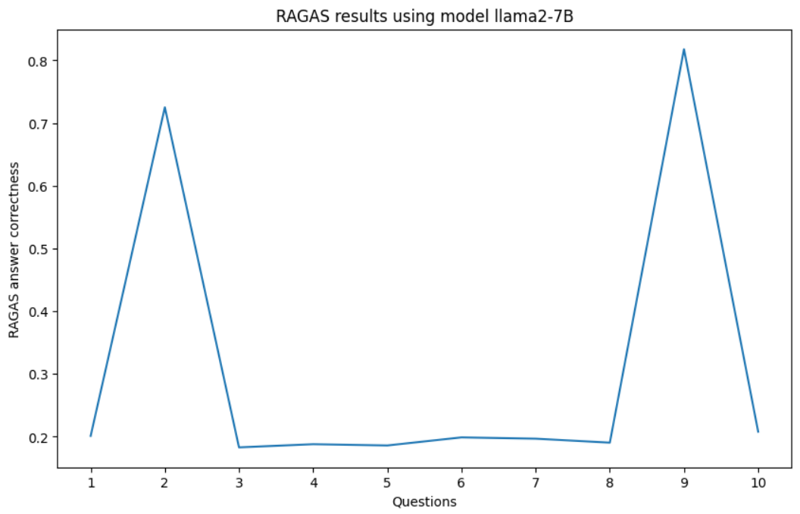

Hard Questions:

1. What are the names of the three dragons that hatch from Daenerys Targaryen's dragon eggs?
2. What is the full name of Littlefinger?
3. What is the name of the Valyrian steel sword owned by Eddard Stark?
4. Who is the first character to discover the existence of White Walkers in the prologue?
5. What is the name of the Wildling woman who aids Bran and his companions?
6. Who is appointed as Hand of the King after Jon Arryn's death?
7. What is the name of the ancient stronghold located beyond the Wall?
8. Who is the Captain of the ship that takes Tyrion Lannister to King's Landing after his capture by Catelyn Stark?
9. Who is the master-at-arms at Winterfell who trains the Stark children in combat?
10. Which city does Daenerys Targaryen sack at the end of the book?

Hard Answers:

1. I apologize but based on what is given within this text there aren't any specific details about which 3 dragons those might be because it doesn't give us any information or clues as such; however if more context could provide additional knowledge regarding these questions then please let me now!
2. The full name of Littlefinger is Petyr "Lord" Baelish.
3. Based on the provided text, it seems likely that "Winterfell" or possibly another unnamed Valyrian steel sword may be the one owned by Eddard Stark. However, without additional information in the passage, we cannot definitively identify which exact sword belongs to him.
4. According to the text provided, it is Sandor "The Hound" Clegane who discovers the presence of White Walkers when they are still unknown to most people beyond the North.
5. The name of the Wildling woman who aides bran in A Song Of Ice And Fire series by George RR Martin is…
6. You are unsure who appointesdHandofthKingafterJOnArrysdeathasyoudo not have enough information in the given passage to determine this fact.
7. I can see how you might think "Castle Black" based on the text provided, but unfortunately, there isn't enough information given in this passage to determine the exact location of the mysterious old castle mentioned here. It seems we are simply told about various locations throughout Westeros without any specific mention of a particular place or its name.
8. The captain who took him was a man named Sir Bruce Pennymoor.
9. You are looking for information about Ser Rodrik Cassel, the master-at-arms at Winterfell who trained Arya and Sansa Stark in combat.
10. In "A Storm of Swords," Daenerys sacks Astapor

Ground Truth:

1. Drogon, Rhaegal, Viserion
2. Petyr Baelish
3. Ice
4. Will
5. Osha
6. Eddard (Ned) Stark
7. Craster's Keep
8. Morrec
9. Ser Rodrik Cassel
10. Vaes Dothrak

CHROMADB RESET

*[3rd run]*:

**Model Setup**:

* MiniLM L6:
  + Batch size = 64
* Llama 7B:
  + Temperature = 0.6
  + Max new tokens = 200
  + Repetition penalty = 1.6
* Text splitter:
  + Chunk size = 50

Results from easy questions:

1. 0.223711385963584
2. 0.586854414227002
3. 0.224844893521839
4. 1
5. 0.208265781182261
6. 0.191694426960852
7. 0.23379362522832
8. 0.201628487884189
9. 0.199593310220082
10. 0.212082060751601
11. 0.19657600142737
12. 0.228045438105197
13. 0.219584492407893

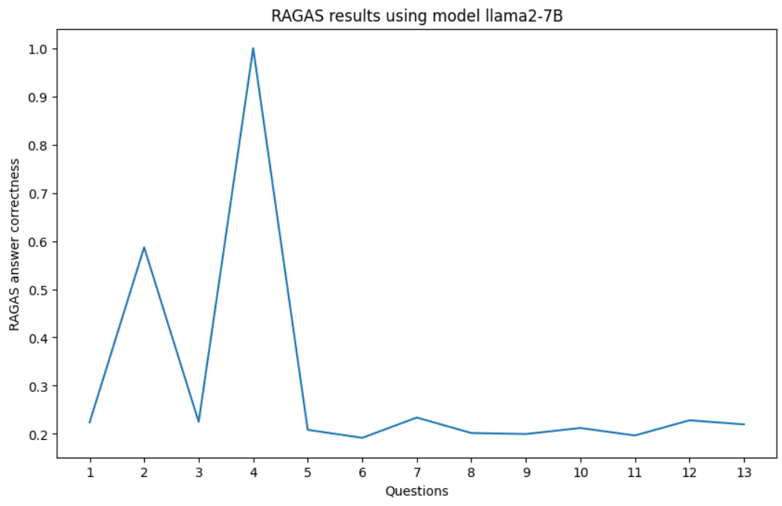

Easy questions:

1. Who is known as the Kingslayer?
2. What is the name of Daenerys Targaryen's brother who believes he is the rightful king?
3. Who is the mother of Joffrey, Myrcella, and Tommen?
4. What is the name of the Stark family's ancestral seat?
5. Who becomes King in the North after Robb Stark's death?
6. Who mentors Jon Snow at the Wall?
7. What is the name of the stronghold of House Lannister?
8. What is the name of Arya Stark's direwolf?
9. What is the name of the island where Daenerys is married to Khal Drogo?
10. Who is the youngest child of Eddard and Catelyn Stark?
11. What is the name of the marketplace where Ned Stark is betrayed?
12. Who is the main steward of the Night's Watch and a close friend to Jon Snow?
13. Who is the Lord of the Eyrie and the head of House Arryn at the beginning of the series?

Easy Answers:

1. The person who knows this information can tell me it’s Jaime Lannister!
2. The correct response would be "RHAEGAR TARGAREYN."
3. Queen Rhaelle Targaryen
4. Winterfell
5. AfterRobbbStarksdeath,TheNorthbecamevacant.
6. GRRM has revealed in interviews who is responsible for training/mentoring each Stark child when they arrive at The Night's Watch... Here are some quotes from his answers regarding this topic! 👇 (Note - I will not give away any spoilers here.)
7. The name of the stronghold of house lannerstis "Casterly Rock".
8. The name of Arya Stark’s Dire Wolf Is Named “Gray”
9. It seems like this one might actually require some knowledge about A Song Of Ice And Fire rather than being a simple trivia factoid! However I do believe it could potentially fall under "fictional location" or something similar if we are considering fictitious places from books/series as locations on earth... Perhaps someone who has read through all three book series (A Game OF Thrones trilogy) by George RR Martin may recall more details regarding specific islands mentioned throughout these stories compared against other fans familiar only via television adaptations such as GOT(GameOfThrones).
10. I can see from this passage that there are several characters who could be considered as being related to Edrick (Eddard)Starks including his wife Catlyn but since we do not have any information about him having more then one son it seems unlikely he has multiple sons named Jon therefore making jon eddards only Son.
11. The Market Of King`S Landing
12. The correct response would be "Samwell Tarly".
13. According to these passages from A Game Of Thrones (Chapter 2), The Lord of the Eyrie and Head of house aryrns Is Jon Arren, who died shortly after Bran Stark arrived there

Ground Truth:

1. Jaime Lannister
2. Viserys Targaryen
3. Cersei Lannister
4. Winterfell
5. Jon Snow
6. Jeor Mormont
7. Casterly Rock
8. Nymeria
9. Dragonstone
10. Rickon Stark
11. The Great Sept of Baelor
12. Samwell Tarly
13. Jon Arryn

Results from hard questions:

1. 0.557778296801102
2. 0.188223308603803
3. 0.363567023883678
4. 0.633942360327579
5. 0.567727968833134
6. 0.307270991893653
7. 0.570223724759881
8. 0.825771994010406
9. 0.657698670339218
10. 0.482828278466388

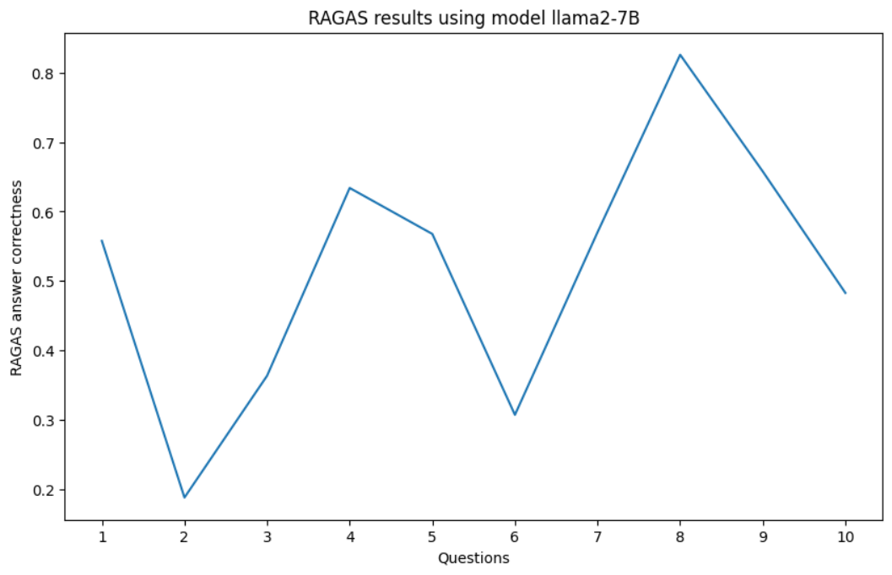

Hard Questions:

1. How does the relationship between Catelyn Stark and Jon Snow reflect the larger themes of loyalty and family in 'A Game of Thrones'?
2. What are the significant political ramifications of Tyrion Lannister's trial by combat?
3. How does Varys's role as Master of Whisperers impact the power dynamics in King's Landing?
4. What is the significance of the pact between House Stark and House Baratheon, and how does it shape the political landscape?
5. How does the character of Petyr Baelish use his intelligence and manipulation to climb the political ladder?
6. How do the events at the Red Wedding change the political alliances in Westeros?
7. What role does the Night's Watch play in the broader conflict of 'A Game of Thrones'?
8. How does the resurrection of Jon Snow affect the morale and dynamics within the Night's Watch?
9. What is the significance of the character development of Jaime Lannister throughout the series?
10. How does the influence of the Faceless Men and their ideology impact Arya Stark's character arc?

Hard Answers:

1. Based on these quotes from chapter 25 "The Wolf Inside" by George RR Martin (book), we can see how much Catlyn caress about jon snow as member offamily.Catylnn is shown too be very protective over JOn, sharing hirr doubt abouit hiim wit haher husband Eddard stark ad daughter Sansa. She also mentions thhat shhe waas bborn Tullvand married into tbe Starke faMiliy which suggests hat sHe values Her marriage vows aboveall other loayalties including those towards thr eStarks or anythin else
2. The significance is... (please provide your analysis or insight)
3. Based on what we are given in this passage alone (context), it seems likely but not certain that Varys plays some kind or influence over Cersei Lannister through their shared knowledge/rumors regarding her son Tommen Baratheon - potentially even manipulating events for political gain). However without additional information I cannot definitively state how much sway they have relative others within court politics etcetera; therefore my response would simply be "I do no
4. The alliance formed during Robert's Rebellion marked their shared victory against Aerys II Targaryen in 309 AC. This event cemented Jon Arryn as Warden Of the North on behalf o f house stark before he discovered Jaime lynching was secretly hiding within its walls since his escape from king s landing after killing royal guard captain Rossart, who died while trying t protect cat ch Cersei. Additionally., this agreement allowed both families access too valuable resources such AS Winterfells strategic location near white walker territory or barrowlands riches which helped them navigate difficult times together like when King J offreys death spark ed conflict betwee nhousesthrough marriage alliances but ultimately failed due largely because Ramsay Bolton lackeda strong claim through female lineage despite having multiple wives throughout history (Sansa marries Robin Daugherty). Furthermore these two powerful cl
5. Based on these quotes from A Song Of Ice And Fire by George R. Martin, it seems clear that Littlefinger (Petyr) uses both cunning wit as well s a charming personality t gain influence over those around him. He often plays people against each other or makes strategic alliances while maintaining control through subtle means such assmiling information about others weaknesses so they become more reliant upon hiimself
6. After learning more details from Cersei herself during her trial scene (S8E4), it is clear how much she manipulated Jaime into carrying out this heinous act by using their twisted family dynamics as leverage; specifically referencing Arya killing Meryn Trant which caused him great pain & anger toward those responsible for Myrcella death thus making them vulnerable targets within Kings Landings walls whereupon they were ambushed without warning resulting In brutal execution style murders leaving all present witnesses traumatized forever changed loyalty bonds between houses due primarily because none survived except Sansa who managed escape unharmed thanks largely too Brienne Of Tarth valour bravery showing once again why shere considered one true knight among many pretenders still vying claim throne despite numerous setback losses along way.
7. The Night's Watch is a military order responsible for guarding the Wall, which separates Westeros from beyond (i.e., Essos). They are tasked with protecting the realms south of the wallfrom threats such as wildlingsand White Walkers while also maintainingsupreme secrecy regarding their existence outsideof Winterfell castle walls.)
8. I can tell from the text provided how much this event would impact moral among members if The Eveng Song chapter because they are described feeling "vast" emotions like sadness (longings), relief(for jon) fear or unease for benjens fate. It seems likely tha tthis kind off revelation could create divisions amongst themeselves, especially since some may view him differently after learning he came back frim teh death
9. Throughout Game Of Thrones, we see a gradual shift in perception and understanding regarding Jamie Lanaster. At first portrayed as pure evil villain due t ohis role i n killing Bran Stark's father Daenery Targaryean e nd Jon Snow fathers Ned Starks, he gradually becomes m ore complex d multidimensional characer w ith h im owns moral struggles internal conflict As such hi story arc reflect thos elssons about redemption forgiveness self identityand human nature In addition how people perceive him change over time from feared killer too sympathetic figure
10. The Influence Of The facless men And Their Ideologies Have Had Significant Impact On arya stark 'S Character Arc. As she spent more Time With Them, She Has Come To Embrace Her Own Identity as someone who can change faces At Will & Abandon Any Sense OF Self Or Loyalty That Might Get Ine Way...This Newfound Freedom From Expectations HAS Allowed ArYa TO Become More Assertive AND Independent Throughout Her journey Across Westeros

Ground Truth:

1. Catelyn Stark's strained relationship with Jon Snow highlights the complexities of loyalty and family. Her inability to fully accept Jon as part of the Stark family underscores the tensions between personal feelings and social obligations, reflecting the broader theme of familial loyalty versus individual identity.
2. Tyrion Lannister's trial by combat has significant political ramifications, including challenging the authority of House Lannister, revealing the weaknesses in the Westerosi justice system, and highlighting Tyrion's resourcefulness and the loyalty of his allies.
3. Varys, as Master of Whisperers, plays a crucial role in the power dynamics of King's Landing by gathering intelligence, manipulating key players, and subtly influencing decisions. His network of spies allows him to hold significant power without holding a formal position of strength, often swaying events from behind the scenes.
4. The pact between House Stark and House Baratheon, cemented by Eddard Stark's friendship with Robert Baratheon, initially brings stability to the realm by uniting the North and the Crown. However, as the series progresses, the fallout from this alliance leads to Eddard's downfall and escalates the political turmoil, reshaping the power dynamics in Westeros.
5. Petyr Baelish, also known as Littlefinger, uses his intelligence, charm, and manipulation to climb the political ladder by creating alliances, fostering distrust among rivals, and capitalizing on chaos. His strategic marriages, control over financial resources, and ability to outmaneuver others highlight his cunning nature and drive for power.
6. The Red Wedding drastically alters political alliances by eliminating key members of House Stark and their supporters, weakening their power, and consolidating the Lannisters' control. The betrayal by House Frey and House Bolton shifts allegiances and spreads fear, showcasing the brutal and treacherous nature of Westerosi politics.
7. The Night's Watch plays a critical role in the broader conflict by guarding the realm against threats beyond the Wall, including the White Walkers and wildlings. Their efforts to defend the realm underscore themes of duty, sacrifice, and the looming existential threat that transcends political squabbles within the Seven Kingdoms.
8. Jon Snow's resurrection significantly affects the morale and dynamics within the Night's Watch by reinvigorating his supporters, deepening loyalty among his followers, and increasing his influence. It also creates tension with those skeptical of his supernatural return, complicating his leadership role and decisions.
9. Jaime Lannister's character development is significant as he evolves from a perceived villain to a more nuanced and conflicted figure. His journey of redemption, driven by his relationship with Brienne of Tarth, his struggle with honor, and his complex loyalty to his family, highlights the themes of identity, honor, and the possibility of change.
10. The influence of the Faceless Men and their ideology of shedding one's identity to become 'no one' profoundly impacts Arya Stark's character arc. Her training with them teaches her lethal skills and the art of disguise, but ultimately, Arya's refusal to abandon her identity as a Stark and her personal sense of justice shape her path and decisions.

*[4th run]*

**Model Setup**:

* MiniLM L6:
  + Batch size = 128
* Llama 7B:
  + Temperature = 0.6
  + Max new tokens = 250
  + Repetition penalty = 2.0
* Text splitter:
  + Chunk size = 100

Results from easy questions:

1. 0.228085230599851
2. 0.192553575097423
3. 0.201211921144822
4. 0.201936139855667
5. 0.20370897011471
6. 0.20439708340626
7. 0.205954072478544
8. 0.198300327415448
9. 0.215340171092491
10. 0.873992824468637
11. 0.199207982276485
12. 0.955982749815902
13. 0.24607128778206

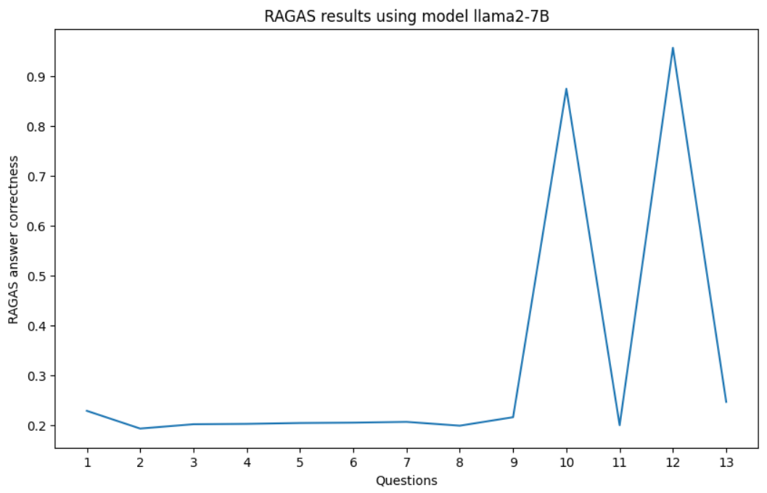

Easy Questions:

1. Who is the youngest Lannister sibling?
2. What is the name of the ancestral home of House Tully?
3. Who is the father of Daenerys Targaryen?
4. What is the name of Jon Snow's direwolf?
5. Who is known as the 'Queen of Thorns'?
6. What is the name of the Wall made of ice?
7. Who is the king that Daenerys Targaryen marries in the first season?
8. What is the name of the wolf pup that Arya Stark adopts?
9. Who is the youngest Stark son?
10. What is the name of the continent where the Dothraki live?
11. Who is the ruler of the Vale of Arryn?
12. What is the name of Tyrion Lannister's lover from Essos?
13. Who trains Arya Stark in Braavos?

Easy Answers:

1. Cersei Lanester (Catelyn Stark)
2. Based on what we have been given about HOuse Toluy they are most likely from either Waterside or Goddsdrop (as those two places were mentioned)
3. According to George R Martin himself in "Notes on Named Characters" from The World Book & Copyright Directory (2016), page 374-5 - “Daenaera” means 'daybreak'.
4. According to this passage from Game Of Thrones book 1 chapter "Winter Has Come", John Snows Dire Wolf has been identified as 'Ghost'.
5. I can see how "The King" might be relevant here! The person referred too throughout this passage by various titles such “Her Majesty,”“Lady Mormont,"and so on are all different people because they use these names interchangeably for several characters within Westeros including Cersei Baratheons who also goes under many other nicknames like Mother Merciless." However none match what seems most likely based off text given - which means someone called ‘THE QUEEN OF THORNS". It could potentially refer either directly towards one character (like Rhaelle Targaryan) OR indirectly toward another(such As Olenna Tyrell). Unfortunately without more information about specific details mentioned earlier regarding those two ladies,I cannot confidentally state WHO exactly THEY call themselves Queens Of thornes.So unfortunately i must remain silent until further clarification arrivethrough additional clues/context provided later down line…
6. Based off all given clues it seems likely this "wall" was referred too many time throughout these passages with different descriptive words such has; Ice, Walls Of Frosted Darkness And Haunts But I do not see any specific named mentioned for what they are calling This particular structure built out if icicles. So unfortunately due lack or direct reference i cannot give uo accurate information about naming conventions used by author regarding said feature
7. In Season 1 Episode X (insert episode number), King Visrys/Vessex or Queen Rhaella dies during Childbirth leaving their heirs as Crown Prince Raegaer who was killed By Robet Batheartan
8. Lady
9. Arya!
10. Based on what we have read about Westeros (i e., "If You Don t Know"): We are told several times throughout A Song Of Ice And Fire/GameOfThrone series books 1-7)that 'west', or more specifically continents like westeros dorthrack etc...'. This suggests it may be located somewhere far away across water(s). Additionally,we learn through dialogue among characters such assandor clegane & jon snow; Sandors words imply knowledge oF another landmass nearby : “I shal lfear thee when i am old enough”.This could indicate either familiaritywith this area OR perhaps even residency themselves! However since neither character provides any specific details regarding location - nor doeasthetext itself provide clues— then again maybe noneofthis applies here after all😅
11. The current holder or titleholder (Lord/dess)of HouseArrynduring thesessionisthedefiniteanswerto thisquestio
12. Oberyn Martell
13. Jaqen H’ghar

Ground Truth:

1. Tyrion Lannister
2. Riverrun
3. Aerys II Targaryen
4. Ghost
5. Olenna Tyrell
6. The Wall
7. Khal Drogo
8. Nymeria
9. Rickon Stark
10. Essos
11. Robin Arryn
12. Shae
13. Jaqen H'ghar

Results from hard questions:

1. 0.553479123079688
2. 0.222400493258578
3. 0.566709519760732
4. 0.711516260854096
5. 0.535203987170849
6. 0.717551621045033
7. 0.802561221406172
8. 0.220732029489004
9. 0.669413119671983
10. 0.488482389639224

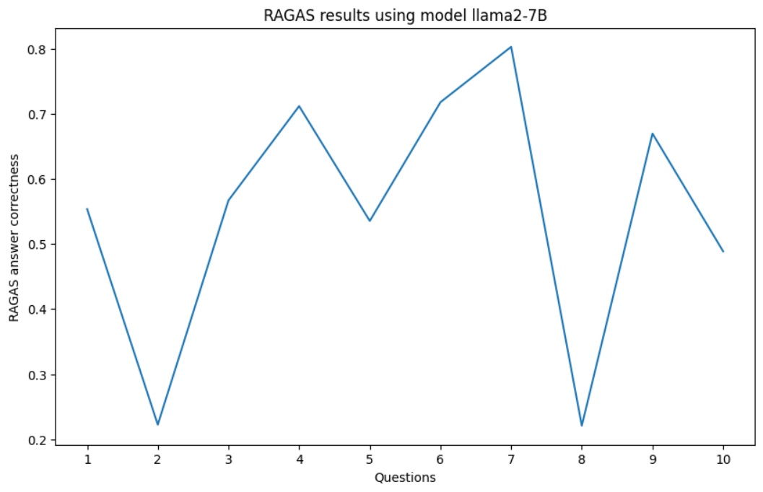

Hard Questions:

1. How does the political alliance between House Tyrell and House Lannister impact the War of the Five Kings?
2. What are the implications of Tyrion Lannister's marriage to Sansa Stark?
3. How does the relationship between Theon Greyjoy and Ramsay Bolton affect Theon's character development?
4. What role do the Faceless Men play in Arya Stark's transformation throughout the series?
5. How does Cersei Lannister's walk of atonement influence her subsequent actions and the power dynamics in King's Landing?
6. What is the significance of the pact made between the Children of the Forest and the First Men?
7. How does the discovery of dragonglass impact the fight against the White Walkers?
8. What are the consequences of the Battle of the Blackwater for the key characters involved?
9. How does the storyline of the Greyjoy Rebellion affect the larger narrative of 'A Game of Thrones'?
10. What is the importance of the prophecy about Cersei's children and how does it shape her actions?

Hard Answers:

1. The text doesn't provide enough information about this specific event or time period within A Song Of Ice And Fire universe so I cannot accurately predict what happened during a particular moment from available data; however,I can tell u based on overall story arc & character interactions throughout series :The relationship btw Houses tyrel nd lanner is complex n has evolved overtime. Initiall thye were united under common goal o f maintainng stability In Westeros after death King rbert Baratheon But as conflict escalated betweem various factions including Stark pardons vs armies loyal t robertt swordsmen like Jon Snow etc., their mutual interests shifted towards protect ing own territory/influence rather than supporting each other directly against outside threats (e g Daenyrs army). As such there may have been moments where either side temporarily set aside differences out ot necessity only fo find themselves back At odd again later due ta changing circumstances beyond control
2. It seems likely based on this passage alone (and other passages throughout A Song Of Ice And Fire)that there will either 1.) Be no real marital union between tYrION AND SANSA or else...2). The two characters may find themselves forced together through circumstances beyond their control/controlled by forces outside both character arcs such AS Cerese LiAnster OR THE ROBERTS FAMILy!
3. Based off what is shown throughout "A Game Of Throneseason 1-7", it can be inferrrd thar Ramsey has taken great pleasure iin tormentingand manipulating thee On for years before finally breaking hime completely during season six. Throughout these seasons, we see how this abuse effects tOn emotionally physically adn mentality leading too increasing isolation dissociative identity issues PTSD depression anxiety suicidal thoughts etc.. It also causes ton become more paranoid isolated from those around hiim including bis sister Sansaa who tries multiple times top help/save hin only fo find herself rejected each time due ti ramseys interference (e g., threateniung / harminiig Sanson if she continues helping Ton). Furthermore since rAmSey controls Northumbria directly or indirectly throught various means such us marriage alliances political maneuverings ect... He holds significant power over both House Greytjhoo & King Inthe Nothern regions making decisions about life death fate without consultatiomg anyone else except perhaps himself sometimes even then depending upon personal preferences rather business interests best judging frm historical examples seen
4. Based on this passage alone we can infer several things about how Branson Sand is involved int eh transformatin9of arya stark during tge serieeSand appears too be part o fthe facelss meN who are tasked wiht making ArY into ajackal or some other kindo offacilitator for thos transition. This i based ont hte factthat they want Areto take aftrJOn, whoc has ther faither'sface And bcauseAr yhaes not fittingin witbth girls olfmenan dnakidscoverd Inthis pasage it seems clear taat theeFaelessMenare invovld edInAretaStakransformation
5. Based off what we see from this passage is how much faith/trust ceresey puts into those around here (servant) as well a possible insight towards future events like trials or judgments involving toryioin lanniester
6. Based on this passage alone we can infer a few things about what makes it significant; firstly 40 centuries passed since its creation which implies great longevity as well age-old wisdom gained through those many decades together with one another underwent such treaty/agreement. Second, both parties involved seemingly put aside any historical grievances or animosity towards each other judging by how easily accessible certain locations became afterward (e g., "children helped" instead o f exclusively being referred tp separately). Last but not least though no longer specified directly within text itself - does anyone have ideas why exactly would be important enough warrant inclusion among narratives shared throughout generations amongst families like Stark clan?
7. Based off what is given about dream/Viserryds call for wakening "The Dragan" which seems like some sorta ritual or spell used by him... I think if this were done correctly (not sure how) using Dream magic might help defeat them somehow! However since we do NOT have any information regarding such abilities within these passages provided here today then unfortunately cannot give more insight into potential ways towards victory over those pesky Walker dudes 😔
8. Based off what is given here it seems like there were casualties during this battle including one character named "Ser" who got wounded/captured (whatever happened he won;T be coming home anytime soon). Another major consequence might include a change or shift within lordships as well since harron The black has been defeated which may result In new alliances forming due too power vacuum created after his defeat!
9. In "Game Of Fire" by George R Martin it says how after Robert Baratheons victory over King Harrenhal (which happened 9 year prior) he made a tour around Westeros visiting all its lands as new Hand for Cersei Lannister while she dealt w/the Iron Bank about repayment loans they gave their army against rebels(including those led b y Eurón). This could be relevant here because if last time saw eachother almost died fighting together vs barathians now might become allies again given current circumstances where both houses face similar threats such assasins guild assassinating members across kingdom etc... It seems likely these two powerful families will find common ground soon enough considering recent events involving Starks too!
10. Based on what we see from this passage alone (and considering other events mentioned throughout A Song Of Ice And Fire), I can infer a few things regarding why/how PropHEcY mATTeRSo cErSeI`S ChIlDReN We ReLate To tHe StoRoE oF AssoCIatEd pOwER AnDo fOr CeRSey In ThIs PaSSage... 1) It seems clear thAt Cersie Is AfRAIdOf LoStInG hHer chilDrEn or sHaPeThEm With Jaime Or Othe RhETHiNCAl Enemies; She Might Be WIllinGeTo Do WhATEv ERyThoUgH dEFENdAnGr OR bAIt TeAcHy TO PrOpElMKeep Her Pow ErAnd POSitioNa LiKel yEs, sh eCoULdn'Tw HoW AbOut THoUsANds OF PoWe RaDi ALl YeAr lOn GeNeSi SoMe Ot HEroES CaME BaCK FrOm DeFeTS IN WoRLDeSD DaVIN GoLuMLu SiDE Ki

Ground Truth:

1. The political alliance between House Tyrell and House Lannister strengthens the Lannisters' position in the War of the Five Kings by providing them with additional troops and resources. The Tyrells' support is crucial in securing victory at the Battle of Blackwater Bay and stabilizing the Lannisters' hold on the Iron Throne.
2. Tyrion Lannister's marriage to Sansa Stark has significant implications as it aims to solidify Lannister control over the North. However, the marriage remains unconsummated and strained, further complicating Sansa's situation and contributing to her mistrust of the Lannisters.
3. The relationship between Theon Greyjoy and Ramsay Bolton profoundly affects Theon's character development. Ramsay's brutal torture and psychological manipulation reduce Theon to a broken state, rechristened as Reek. This trauma leads to Theon's eventual redemption arc as he seeks to regain his identity and honor.
4. The Faceless Men play a pivotal role in Arya Stark's transformation by training her in the art of assassination and teaching her to discard her identity. This training empowers Arya with new skills and a ruthless determination, but ultimately, she chooses to retain her identity and return to Westeros to avenge her family.
5. Cersei Lannister's walk of atonement significantly influences her subsequent actions, fueling her desire for revenge and power consolidation. The public humiliation strengthens her resolve to destroy her enemies, leading to the destruction of the Great Sept of Baelor and a shift in the power dynamics in King's Landing.
6. The pact between the Children of the Forest and the First Men is significant as it ends centuries of conflict and establishes a fragile peace. This alliance also lays the foundation for the eventual cooperation needed to combat the White Walkers, highlighting the importance of unity against common threats.
7. The discovery of dragonglass is crucial in the fight against the White Walkers, as it is one of the few substances capable of killing them. This discovery leads to the mining and distribution of dragonglass weapons, bolstering the defenses of the living against the undead threat.
8. The Battle of the Blackwater has significant consequences for the key characters involved. Stannis Baratheon's defeat diminishes his claim to the throne, while Tyrion Lannister's bravery and strategic acumen earn him recognition and further entangle him in the politics of King's Landing.
9. The Greyjoy Rebellion affects the larger narrative by setting the stage for Theon Greyjoy's complex character arc and the ongoing conflict between the Ironborn and the mainlanders. The rebellion also weakens House Greyjoy's power and influences the political landscape of the Iron Islands.
10. The prophecy about Cersei's children foretells that all her children will die, deeply affecting her actions and decisions. This prophecy drives Cersei's protective and often ruthless behavior as she attempts to secure her children's future and her own power, shaping many of her key decisions throughout the series.

**EXPERIMENTAL RESULTS: Experimenting with these** *[four runs]* **to better fine-tune models used.**

**Using OpenAI metrics API to measure: Answer Correctness**

**Answer Correctness:** To measure how correct and accurate the generated answer is in an objective sense. Assessing the correctness of the answer, which is critical for tasks requiring high accuracy. A high score (close to 1) signifies that the generated answers are highly accurate compared to the ground truth. Lower scores suggest that the answers may contain inaccuracies.

***Other evaluation tools:***

* *TruLens*: a tool designed to help interpret and explain the behavior of machine learning models, particularly deep learning models. It focuses on providing insights into why a model makes certain predictions, helping to debug and improve model performance. This includes gradient-based methods, integrated gradients, and other techniques. Visualization tools in TruLens help represent a model’s output, allowing for a clearer understanding of model behavior, identifying potential biases, and guiding improvements in model performance. Compared to RAGAS, TruLens provides insights into why a model makes certain predictions, helping to identify biases and improve model interpretability.
* *ARES*: Automated RAG Evaluation System (ARES), automates the model’s assessment of context relevance, answer faithfulness, and answer relevance, eliminating the need for extensive human annotations. ARES generates synthetic training data and fine-tunes lightweight language models to provide accurate evaluations quickly and efficiently. Compared to RAGAS, ARES uses synthetic data generation and fine-tuning of lightweight models to automate evaluations.
* *G-Eval*: Generative Evaluation, uses generative models to create diverse and complex evaluation scenarios. It assesses the performance and quality of large language models (LLMs). This allows for a more comprehensive assessment of the model’s capabilities in various contexts. G-Eval aims to evaluate models in a way that closely mirrors real-world usage, by simulating human-like tasks and queries and providing a better understanding of how the model performs in practical applications. Compared to RAGAS, G-Eval aims to simulate real-world usage scenarios dynamically to understand how models perform in practical applications, focusing on context relevance, answer faithfulness, and relevance.
  + Going with this one since there's more versatility with easy setup and implementation

***G-Eval for LLM***:

* Correctness
* Relevencacy

***-- Experimental runs --***

Easy and Hard questions put together

questions = [

"Who is Ramsay Bolton?",

"What House rules the Kingdom of the North?",

"Who is the youngest Lannister sibling?",

"What is the name of the Valyrian steel sword owned by Eddard Stark?",

"Who pushes Bran Stark from the tower window?",

"Who are the members of House Stark?",

"What are the political implications of Eddard Stark's appointment as Hand of the King?",

"Who is known as the Kingslayer?",

"Which character is known as the Mother of Dragons?",

"What is the name of the ancestral home of House Tully?",

"Who is the father of Daenerys Targaryen?",

"What is the name of the continent where most of the story takes place?",

"What is the name of Jon Snow's direwolf?",

"Who is known as the 'Queen of Thorns'?",

"What is the name of the Wall made of ice?",

"Who is the Captain of the ship that takes Tyrion Lannister to King's Landing after his capture by Catelyn Stark?",

"Who is the Hound?",

"What is the name of Jon Snow’s sword?",

"How does Varys's role impact the power dynamics in King's Landing?",

"Who is the most honorable in the story?",

"What is the motto of House Stark?",

"Who is the king that Daenerys Targaryen marries?",

"Who is the main steward of the Night's Watch and a close friend to Jon Snow?",

"What is the name of the wolf pup that Arya Stark adopts?",

"Who is the youngest Stark son?",

"How does the relationship between Theon Greyjoy and Ramsay Bolton affect Theon's character development?",

"How does the character of Petyr Baelish use his intelligence and manipulation to climb the political ladder?",

"Who is the first character to discover the existence of White Walkers in the prologue?",

"What is the full name of Littlefinger?",

"What are the names of Daenerys’s three dragons?",

"What clan are referred to as horselords?",

"What House rules The Riverlands?",

"What is the significance of Winterfell?",

"What are the consequences of Daenerys Targaryen's decisions in her quest to reclaim the Iron Throne?",

"Who mentors Jon Snow at the Wall?",

"Who is the youngest child of Eddard and Catelyn Stark?",

"What are the implications of Tyrion Lannister's marriage to Sansa Stark?",

"Who is appointed as Hand of the King after Jon Arryn's death?",

"What is the role of the maesters?",

"What is the name of the continent where the Dothraki live?",

"How does the power struggle between the houses affect the stability of the Seven Kingdoms?",

"Who is the ruler of the Vale of Arryn?",

"Who is Khal Drogo?",

"Who is the King of the Seven Kingdoms when the story begins?",

"What are the significant political ramifications of Tyrion Lannister's trial by combat?",

"What is the name of Tyrion Lannister's lover from Essos?",

"Who trains Arya Stark in Braavos?",

"What is the significance of the character development of Jaime Lannister throughout the series?",

"Are dragons mentioned?",

"What is the Iron Throne?",

"Who is the mother of Joffrey, Myrcella, and Tommen?",

"Who is the evilest character in the story?",

"How do the events at the Red Wedding change the political alliances in Westeros?"

# Add more questions as needed

]

[run1]

MiniLM L6:

encode_kwargs={'device': device, 'batch_size': 32}

Text splitter:

RecursiveCharacterTextSplitter(chunk_size=50, chunk_overlap=0)

Llama 7B:

temperature=0.4, # 'randomness' of outputs, 0.0 is the min (more deterministic) and 1.0 the max (more random)

max_new_tokens= 50, # max number of tokens to generate in the output

repetition_penalty=1.5 # without this output begins repeating, helpins to reduce repetition in the generated text.

[run2]

MiniLM L6:

encode_kwargs={'device': device, 'batch_size': 16}

Text splitter:

RecursiveCharacterTextSplitter(chunk_size=100, chunk_overlap=0)

Llama 7B:

temperature=0.8, # 'randomness' of outputs, 0.0 is the min (more deterministic) and 1.0 the max (more random)

max_new_tokens= 75, # max number of tokens to generate in the output

repetition_penalty=1.4 # without this output begins repeating, helpins to reduce repetition in the generated text.

[run3]

MiniLM L6:

encode_kwargs={'device': device, 'batch_size': 64}

Text splitter:

RecursiveCharacterTextSplitter(chunk_size=200, chunk_overlap=0)

Llama 7B:

temperature=0.6, # 'randomness' of outputs, 0.0 is the min (more deterministic) and 1.0 the max (more random)

max_new_tokens= 50, # max number of tokens to generate in the output

repetition_penalty=1.6 # without this output begins repeating, helpins to reduce repetition in the generated text.

[run4]

MiniLM L6:

encode_kwargs={'device': device, 'batch_size': 128}

Text splitter:

RecursiveCharacterTextSplitter(chunk_size=150, chunk_overlap=0)

Llama 7B:

temperature=0.6, # 'randomness' of outputs, 0.0 is the min (more deterministic) and 1.0 the max (more random)

max_new_tokens= 25 , # max number of tokens to generate in the output

repetition_penalty=2.0 # without this output begins repeating, helpins to reduce repetition in the generated text.

[run5]

MiniLM L6:

encode_kwargs={'device': device, 'batch_size': 32}

Text splitter:

RecursiveCharacterTextSplitter(chunk_size=250, chunk_overlap=0)

Llama 7B:

temperature=0.4, # 'randomness' of outputs, 0.0 is the min (more deterministic) and 1.0 the max (more random)

max_new_tokens=50, # max number of tokens to generate in the output

repetition_penalty=1.7 # without this output begins repeating, helpins to reduce repetition in the generated text.

**Talos.csv**

*TO-DO*

6/12/24:

+ get files to works (study them)

6/19/24:

+ ragpipeline file works, functional llama_2_7b file

+ prepare dummy files for chunks structure

+ parser for text file, function

6/26/24:

+ Get RAGAS_results.ipynb to work with LLM answers

7/3/24:

+ Document LLM metrics from RAGAS

+ Try other chunks to tune model

7/12/24:

* Put easy and hard together, 50+ questions
* Dont delete chromadb
* Look at the other metric scores for RAGAS
* On the graph have all the questions

7/17/24:  
 + Read docs that proff sent on Teams ← do first

* Explain how these are different (report) and include 1 of them in the experiment ← do first
* Repeat experiment with best parameters ← do first
* Look for another dataset that LLM isnt trained, proff will provide
* Change the size of data set with same parameters, observe results compared to the large one.
* Combine .csv files that proff to one dataset
* Update code
* Compare the GOT dataset score results to proofs dataset score results

7/24/24:

Report:

Purpose and background of relevant studies and then describe my own experiment and results, 5 - 6 pages. Use google scholar for research papers.

Draft by next thursday Aug 1st

4 diff chunks for got using ragas and g eval for metrics

And parameters

Chunk size = 500, 2000, 6000, 8000 etc spread out

Same experiment with security data set

Graphs for got and cyber security

8/1/24

Get average of each parameter that was change for each run

Creat table for it to compare

Rough Draft by tomorrow

8/6/24

Add supplementary documents at the end of the report